ALZHEIMER DISEASE PREDICTION USING DEEP LEARNING TECHNIQUE

**ABSTRACT-** The AD is the most common form of dementia throughout the world. From the least to the severe, which renders all work impossible without support, it progresses over time. This has increased, and this is primarily because of population aging as well as late-stage diagnoses. It attempts to identify people by combining medical history, cognitive testing, and MRI scanning. Such methods, however, are not always reliable and face various limitations. Thus, this study extends previous studies that attempt to utilize the CNN-based approach to detect abnormalities in MRI images associated with AD. It develops high-resolution illness-probability maps relating individual brain regions to multi-layered perceptron models. The new approach considers both the four stages of dementia and individual diagnoses. Easy-to-understand visual representations are included. To avoid class imbalance, samples must be equidistributed across the four types of MRI images. According to the DenseNet264 method, the spectrum of mental instability is from "very slightly deranged" to "slightly demented" and further to "moderately insane," with "not demented" being the least disturbed. Data on MRI scans downloaded from Kaggle reflects a very serious problem of class imbalance. It has been proposed to use a DenseNet264 classification method on MRI data to be able to identify the different phases of dementia. A prediction of AD classes for the Alzheimer's Disease Neuroimaging Initiative (ADNI) dataset is performed to examine the performance of the proposed approach.

**Keywords:** Magnetic Resonance Imaging, Alzheimer’s disease, Demented, Convolutional Neural Network.

# I INTRODUCTION

The ability to employ computational neuroscience for translational purposes has been tremendously helpful to epidemiological studies of mental health. To better understand the mechanisms underlying clinical symptoms, this interdisciplinary field of study may prove useful in simulating the biological processes that occur in the human brain in both healthy and sick states. Neurodegenerative and

neuropsychiatric diseases have profited from the expansion of machine learning (ML) and big biological datasets in the recent decade. The fundamental impetus for this effort is the use of magnetic resonance imaging, which is both easy to learn and offers a precise location for calcification and foreign masses. MRI is the gold standard for visualizing AD and its associated environments. AD is a form of dementia that can be both sudden and devastating. Every four seconds, a new case of AD is discovered, and it is a tragedy for the person diagnosed and their loved ones. Dementia is characterized by a decline in cognitive capacities such as reasoning, social and emotional coping, and independent functioning; Alzheimer's disease (AD) is the most common form of dementia. As the condition progresses, the sufferer will forget everything they have ever experienced, starting with recent events. Thus, an early diagnosis of the condition is crucial. A model that can take an MRI scan of the brain as input and output a diagnosis of dementia at the mild, moderate, very mild, or absence levels. Dementia is defined by severe difficulties in everyday life that hinder independence, much as mild dementia is defined by cognitive impairment and poor performance on an objective cognitive testing that reflects a decrease from the past. In the intermediate stage of AD, individuals are more confused and forgetful and require more help with activities of daily living and self-care. Intermediate-stage dementia patients with AD may: show worsening judgment and increasing confusion. Alzheimer's patients who do not have dementia A "neuropathology" is a situation in which a person exhibits the neuropathology often associated with the onset of full-blown AD symptoms yet retains cognitive capacity (NDAN). Intermediate dementia is a form of the disease that occurs between the normal aging-related decrease in memory and cognition and severe dementia. There are 12,500 improved photographs in the collection (JPEG) Each of the four AD types has its own separate file containing around 86,000 pictures (according to AD type). Degeneration of brain tissue might be classified as mild, moderate, very mild, or no dementia at all.

# II.LITERATURE SURVEY:

Blennow.K, et.al (2021) [1] proposed Prediction of future Alzheimer's disease dementia using plasma phospho-tau combined with other accessible measures A combination of plasma phospho-tau (P-tau) and other accessible biomarkers might provide accurate prediction about the risk of developing

Alzheimer's disease (AD) dementia. We examined this in participants with subjective cognitive decline and mild cognitive impairment from the Bio FINDER (n = 340) and Alzheimer's Disease Neuroimaging Initiative (ADNI) (n = 543) studies. AD-specific magnetic resonance imaging were examined using progression to AD as outcome The clinical predictions by memory clinic physicians had significantly lower accuracy (4-year AUC = 0.71). In summary, plasma P-tau, in combination with brief cognitive tests and APOE genotyping, might greatly improve the diagnostic prediction of AD and facilitate  
recruitment for AD trials.  Candice Ee Aang, et.al (2021) [2] Application of Artificial Intelligence techniques for the detection of Alzheimer’s disease using structural MRI  
images Alzheimer’s disease (AD) is an irreversible, progressive brain disorder that slowly destroys memory and thinking skills. It is one of the leading types of dementia for persons aged above 65 worldwide. In order to achieve accurate and timely diagnosis, and for detection of AD in its early stages, numerous Artificial Intelligence (AI) based Computer-aided Diagnostic (CAD) approaches have been proposed using data from brain imaging. In this paper, we review the recent application of AI based CAD systems on AD and its  
stages, with a particular focus on the use of structural MRI. Summarize contributions from different research groups, critically discuss challenges involved and propose directions for future research. Ultimately, it would be ideal for development of a diagnostic framework that could be applicable to not only AD, but to different types of dementia as well in the future.  Chandran Venkatesan, et.al (2021) [3] proposed A Deep Learning Model for Early Diagnosis of Alzheimer Diseases and Dementia from MR Images Alzheimer’s disease (AD) is the most common cause of dementia globally. By considering four stages of dementia and conducting a particular  
diagnosis, the proposed model generates high-resolution disease probability maps from the local brain structure to a multilayer perceptron and provides accurate, intuitive visualizations of individual Alzheimer’s disease risk. To  
avoid the problem of class imbalance, the samples should be evenly distributed  
among the classes. The obtained MRI image dataset from Kaggle has a major class imbalance problem. A Dementia Network (DEMNET) is proposed to detect the dementia stages from MRI. The DEMNET achieves an accuracy of 95.23%, Area under Curve (AUC) of 97% and Cohen’s Kappa value of 0.93  
from the Kaggle dataset, which is superior to existing methods. We also used the Alzheimer’s disease Neuroimaging Initiative (ADNI) dataset to predict AD classes in order

to assess the efficacy of the proposed model.  Jhansi, et.al (2021) [4] proposed Alzheimer Disease Detection using Correlation based Ensemble Feature Selection and Multi Support Vector Machine In recent decades, machine learning techniques have been playing a  
crucial role in the field of computer aided diagnosis. Initially, an adaptive histogram equalization and region growing are employed on the collected brain scans for contrast improvement and skull removal. Next, Fuzzy C Means  
(FCM) clustering algorithm is applied in the enhanced brain scans to segment tissues like White Matter (WM), Cerebral Spinal Fluid (CSF), and Grey Matter (GM). Ina addition, feature extraction is accomplished in the segmented brain tissues using Gabor and local directional pattern variance features. In order to decrease the dimension of the extracted feature vectors, the correlation based  
on ensemble feature selection algorithm was proposed. The Alzheimer disease using machine learning algorithms is successfully implemented and gives greater prediction accuracy results.  Yamini T, et.al (2022) [5] proposed Alzheimer’s disease is the most common form of dementia affecting the brain’s parts. A broad term used to describe illnesses and conditions that causes a deterioration in memory, language, and other cognitive abilities severe enough to interface with daily life is “dementia”. According to estimates, this disease affects 6.2 million Americans and 5 million people in India aged 65and older. In 2019, the most recent year for which data are available, official death certificates reported 121,499 deaths from AD, making Alzheimer’s the “sixth leading cause of death in the country and the fifth leading cause of death for people 65 and older”. In this paper, we suggest several machine Learning algorithms like Decision trees, SVM, Logistic regression, and Naive Bayes identify AD at an early stage. The Alzheimer\'s Disease Neuroimaging Initiative (ADNI) and the Open Access  
Series of Imaging Investigations (OASIS) provide data sets white used to detect the disease in its early stage. The datasets consist of longitudinal MRI data (age, gender, mini mental status, CDR) By taking into account many factors in each method, such as precision, F1 Score, Recall, and specificity are calculated. The results obtained 93.7% of maximum accuracy for the Decision Tree Algorithm.  Kavitha C, et.al (2022) [6] proposed Alzheimer's disease (AD) is the leading cause of dementia in older adults. There is currently a lot of interest in applying machine learning to find out metabolic diseases like Alzheimer's and Diabetes that affect a large population of people around the world. Their incidence rates are increasing at an alarming rate every year. In Alzheimer's disease, the brain is affected by neurodegenerative changes. As our aging population increases, more and more individuals, their families, and healthcare will experience diseases that affect memory and functioning. These effects will be profound on the

social, financial, and economic fronts. In its early stages, Alzheimer's disease is hard to predict. A treatment given at an early stage of  
AD is more effective, and it causes fewer minor damage than a treatment done  
at a later stage. Several techniques such as Decision Tree, Random Forest, Support Vector Machine, Gradient Boosting, and Voting classifiers have been employed to identify the best parameters for Alzheimer's disease prediction. Predictions of Alzheimer's disease is based on Open Access Series of Imaging Studies (OASIS) data, and performance is measured with parameters like  
Precision, Recall, Accuracy, and F1-score for ML models. The proposed classification scheme can be used by clinicians to make diagnoses of these diseases. It is highly beneficial to lower annual mortality rates of Alzheimer's disease in early diagnosis with these ML algorithms. The proposed work shows better results with the best validation average accuracy of 83% on the test data  
of AD. This test accuracy score is significantly higher in comparison with existing works.  Vijeeta patil, et.al (2022) [7] proposed a comprehensive review on Alzheimer's disease (AD) is carried out, and an exploration of the two-machine learning (ML) methods that help to identify the disease in its initial stages. Alzheimer's disease is a neurocognitive disorder occurring in people in their early onset. This disease causes the person to suffer from memory loss, unusual behavior, and language problems. Early detection is essential for developing more advanced treatments for AD. Machine learning (ML), a subfield of  
Artificial Intelligence (AI), uses various probabilistic and optimization techniques to help computers learn from huge and complicated data sets. To diagnose AD in its early stages, researchers generally use machine learning. The survey provides a broad overview of current research in this field and  
analyses the classification methods used by researchers working with ADNI data sets. It discusses essential research topics such as the data sets used, the evaluation measures employed, and the machine learning methods used. Our presentation suggests a model that helps better understand current work and  
highlights the challenges and opportunities for innovative and useful research. The study shows which machine learning method holds best for the ADNI data set. Therefore, the focus is given to two methods: the 18-layer convolutional network and the 3D convolutional network. Hence, CNNs with multi-layered fetch more accurate results as compared to 3D CNN. The work also contributes to the use of the ADNI data set, where the classification of training and testing  
samples is divided with such a number that

# III METHODOLOGY

Here, we focus on utilizing deep learning (DL) algorithms to detect Alzheimer’s disease (AD) through medical imaging analysis. Specifically, our approach leverages convolutional neural networks (CNN) and transfer learning models to classify different stages of Alzheimer's—Non-Demented, Very Mild Demented, Mild Demented, and Moderate Demented. We utilize a public dataset obtained from Kaggle, containing MRI scans of Alzheimer's patients, with a total of 86,000 images equally distributed across the four categories (21,500 images per category). The dataset undergoes preprocessing, where all MRI images are resized to 224x224 pixels to ensure uniformity for model input. After preprocessing, we apply two prominent transfer learning models: DenseNet and VGG16. These models are pre-trained on large image datasets and are highly efficient for feature extraction and classification. Transfer learning allows us to adapt these models for our Alzheimer's prediction task by modifying the final layers to match our specific requirements. DenseNet and VGG16 help in feature learning through their deep convolutional layers, which capture intricate details from the MRI images. In our architecture, we constructed a convolutional sequence model trained over 30 epochs. The model comprises multiple convolutional layers that extract features from the input images, followed by a Flatten layer, which reshapes the multidimensional output into a 1D vector. This flattened output is then passed through a Dense layer, which adjusts the dimensionality of the data to make the final classification into one of the four dementia stages. We employ the ReLU (Rectified Linear Unit) activation function within the convolutional and dense layers to introduce non-linearity, allowing the model to learn complex patterns in the data. The final Dense layer uses a SoftMax activation function to output a probability distribution over the four classes, enabling precise stage prediction of Alzheimer’s disease. This combination of CNN-based feature extraction, transfer learning, and carefully tuned layers forms the backbone of our approach to accurately identify Alzheimer’s progression.

## 2.Data preprocessing

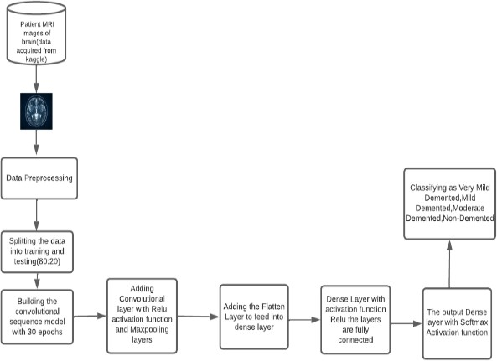

F**ig 1** Proposed Architecture

## 1.Data acquisition

The initial step is to gather images. To create a classification model, the computer must learn by doing. To recognize an object, the computer must examine a large number of images. Deep learning models can also be trained using other types of data, such as time series data and voice data. Images are important information needed to identify AD in the context of the work discussed in this article. This step produces images that will be used to train the model later.



**Fig 2** Representation of Data Acquisition

The image classification task assigns a class to a given MRI image. It is a basic high-level image comprehension task that can be divided into two and multi-classification tasks. The image is classified according to the requirements to the output layer after several convolution and fusion operations through CNN. The only difference between binary and multiclassification tasks is function of activation of the output layer. The job of image classification for MRI image analysis is readily recognized, allowing the essential steps to be made for determining the kind of dementia for which natural picture classification is high, including the usage of Convolutional Neural Network (CNN) to categories JPG/PNG images.



**Fig 3** Representation of Data Preprocessing

## Feature extraction

Feature extraction is done to reduce features in the dataset, in this module, we perform some additional operations on the segmented image. In this module, we will use feature extraction to obtain all of the detailed information about a brain image. In the fields of computer vision and machine learning, feature extraction and reduction have played a crucial role in the classification of tumor areas. The main problem with feature extraction is determining which features are the most active or robust for classification, resulting in an efficient performance. Feature extraction is used in dimensionality reduction.

## Magnetic resonance imaging classification

Radio waves and magnetic fields are used to create high-quality 2D and 3D brain images. No radioactive tracers or X-rays are produced. Structural MRI, which assesses brain volume in vivo to detect brain deterioration, is most commonly used in AD (loss of tissue, cells, neurons, and so on). Alzheimer's causes brain degeneration. Structural MRI detects brain atrophy. Functional magnetic resonance imaging is another popular method for examining the primary visual cortex and brain topography (fMRI). fMRI provides crucial brain function data. Arterial blood oxygen level- dependent brain imaging technologies detect cerebral oxygen consumption and CBF metabolic rate contrasts and spin labelling (ASL).

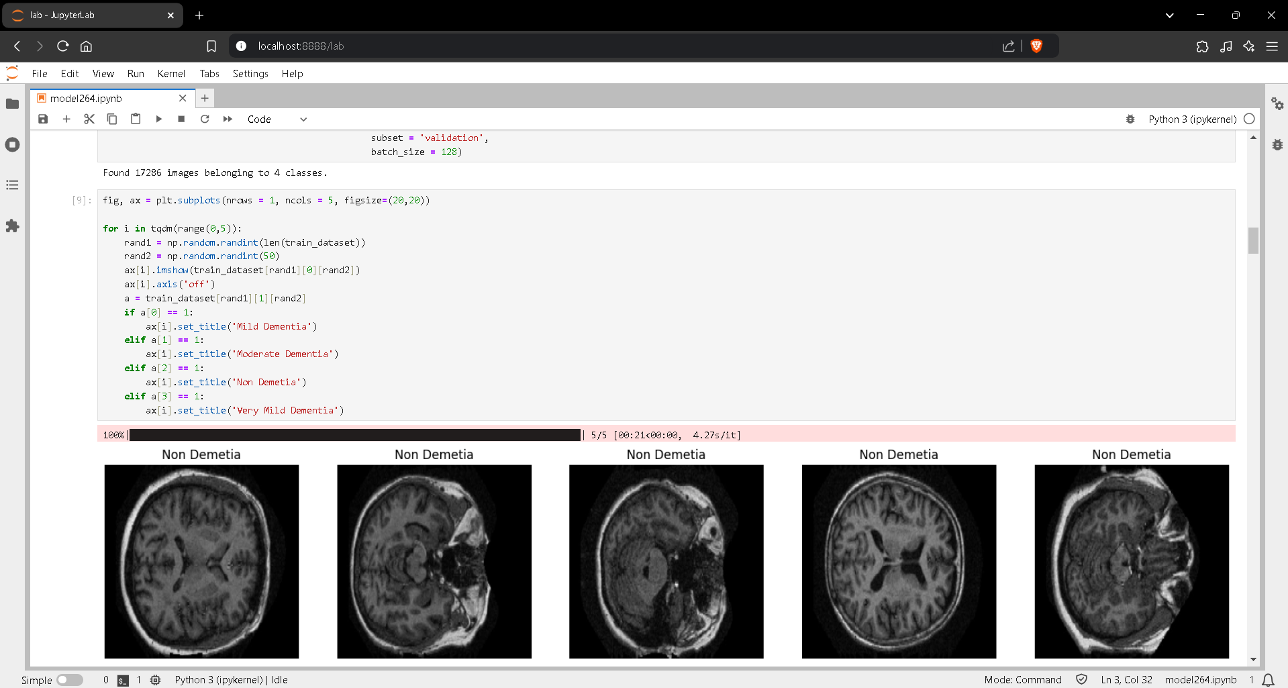

**Fig 4** Representation of MRI Image Classification

## CNN Model

Classifying a picture requires extracting features from the image to recognize dataset patterns. ANN's high parameter training makes photo classification computationally expensive. For example, a typical ANN can be trained to classify a 50 × 50 cat picture as either a dog or a cat using width and height. –(50*50) * 100 image pixels times hidden layer + 100 bias + 2 * 100 output neurons + 2 bias = 2,50,30 Filters use a local connection pattern across neurons to leverage a picture's spatial localization. Convolution is pointing wise multiplication of two functions to create a third. Hence, a filter and a matrix of picture pixels are functions. Gliding the filter across the picture yields the dot product of the two matrices. "Activation Map" or "Feature Map" describes this matrix.

Step 1: Choose a Dataset

You may choose a dataset of interest or construct your own picture dataset to solve your own image classification challenge. On kaggle.com, selecting a dataset is simple. The dataset I will be using may be found here.

12,500 enhanced photos of (JPEG) There are roughly 3,000 photos for each of the four categories of AD organized into four distinct files (according to AD type). Mild, Moderate, Very Mild, and No Dementia are the cell kinds. Here, we use a number of t libraries that need their importation code.

Step 2: Prepare Training Dataset

Assigning paths, labels, and resizing photographs will prepare our dataset for training. Resizing photographs to 224x224

Step 3: Training data is an array of picture pixel values and the image's CATEGORIES index.

Step 4: Shuffle Dataset step5: Label and Feature

NEURAL NETWORKS will classify these listings. Step 6: Normalizing X and categorizing labels.

Step 7: Separate CNN-use X and Y.

Step 8: Define, build, and train CNN Model Step 9: Model score and accuracy.

The Dense net and VGG16 models classify AD type.

## Dense Networks (Dense Net)

Gradients that disappear or erupt make training very deep neural networks problematic. A skip link can solve this problem by feeding a layer's activation unit to a deeper network layer. Dense networks start here. As neural networks add layers, training error should monotonically decrease. Yet, a typical neural network will eventually increase training error. Dense Nets are unaffected. More network layers will reduce training error. Dense Nets can train 1000- layer networks. Dense Network for image categorization Let's build a 50-layer Keras Dense Net for image categorization. TensorFlow, CNTK, and Theano-compatible Keras. It was designed for fast experimentation. The backend is TensorFlow. Please import all notebooks before starting.

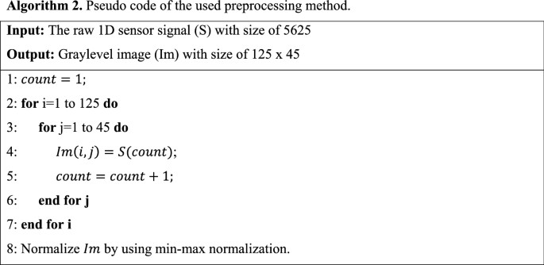

**Fig 5** Pseudocode Representation of the Algorithm

1. **VGG16 Implementation**

The entire architecture uses convolution and max pool layers. Two FC (fully connected layers) and a SoftMax output finish it. VGG16 means 16 weighted layers. 138 million parameters make this network large. Importing all VGG16 libraries here. Creating a sequential model requires the Sequential technique. Sequential model organizes model layers consecutively. Keras preprocessing loaded Image Data Generator. Image Data Generator adds labels to the model. This class has many useful methods for resizing, rotating, zooming, and flipping. This class does not affect disk-stored data. This class alters data supplied to the model.

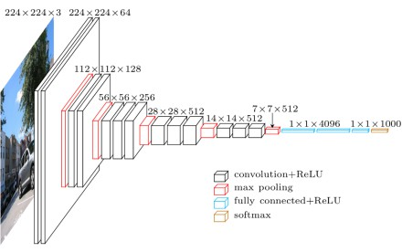

**Fig 6** VGG16 Architecture Diagram

**RESULTS:**

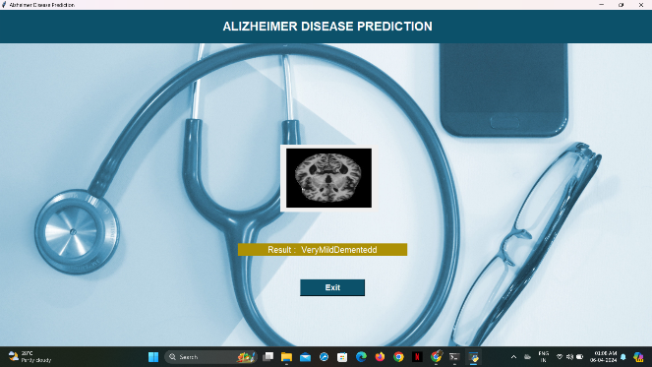

**Fig 7** Representation of Very Mild Dementia

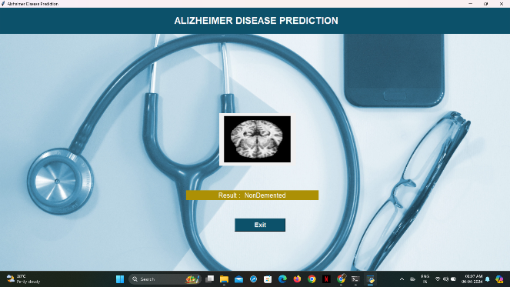

**Fig 8** Representation of Non Dementia

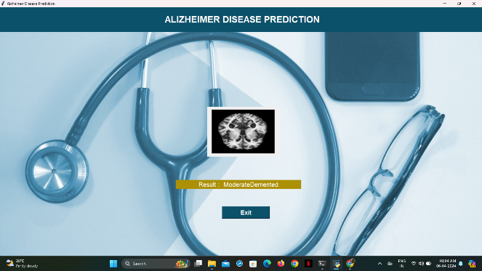

**Fig 9** Reprsentation of Moderate Dementia

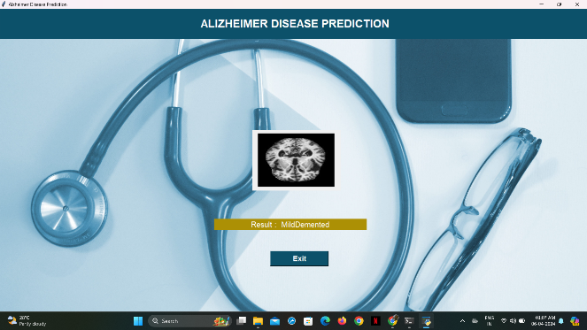

**Fig 10** Representation of Mild Dementia

## IV.Experimental Analysis

A part of the test data was evaluated to determine how well the classifiers predicted AD patients following cross-validation. Visualizing the uncertainty matrix allowed classifier evaluation. to test machine learning classifiers Adult-onset dementia's brain shrinkage and cognitive decline substantially damage people's lives. About 60–70% of dementia cases in adults worldwide are related to AD, the most frequent form of dementia. As mentioned in the introduction, clinical and exclusion criteria were used to diagnose AD, which can only be proven postmortem. On the other hand, an accurate and early diagnosis of AD is critical for the prompt adoption of therapies to enhance brain health. Preclinical screening of AD-vulnerable individuals may help identify the disease's mechanism and improve treatment. Existing AD biomarkers required MRI data or sample collection (such as serum or fluid) (such as serum or fluid).

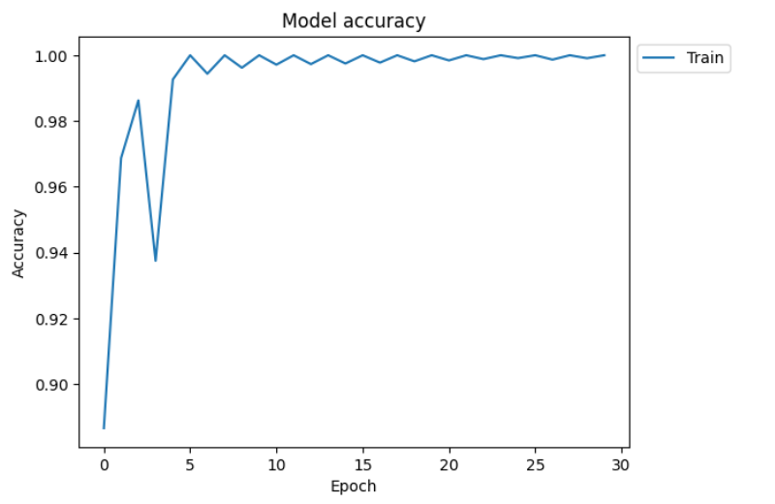

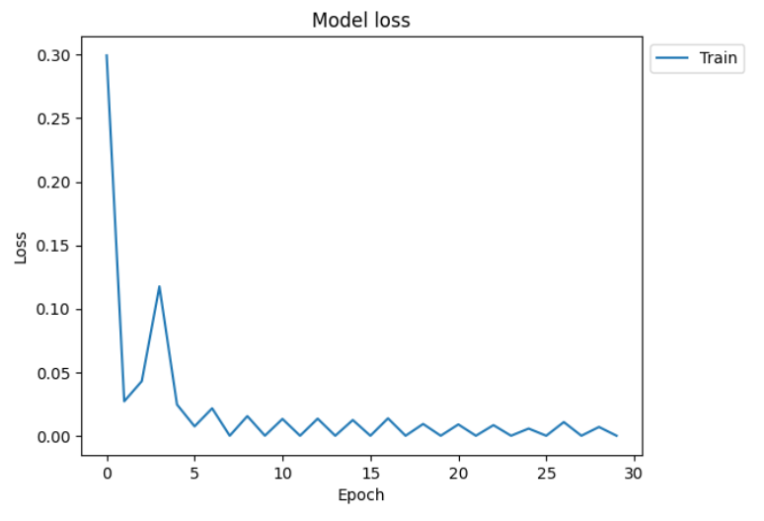

**Fig 11** Graphical analysis

# V.CONCLUSION

In this paper, we proposed a straightforward and reliable classification method for AD MRI scans. The method is based on a visual content description of the hippocampal region, a brain region associated with AD. We suggested fusing the classification outcomes with the hippocampus and CSF as two biomarkers. Studies revealed that combining hippocampal characteristics with CSF volume classification improved accuracy, particularly when separating AD from MCI, compared to using either visual characteristics or CSF volume calculation alone. Comparing the proposed method to other volumetric methods, we showed that it offers a higher level of classification accuracy. We intend to make use of various ROIs and MRI techniques within the pre-existing classification framework in this work.

# REFERENCES:

[1] Allan I. Levey, et al. “Progress with Treatments for Alzheimer’s Disease” in the NEW  
ENGLAND JOURNAL of MEDICINE, (2021). DOI: 10.1056/NEJMe2103722

[2] Arya, A. D., Verma, S. S., Chakarabarti, P., Chakrabarti, T., Elngar, A. A., Kamali, M., &  
Nami, M. (2023). A systematic review on machine learning and deep learning techniques in the  
effective diagnosis of Alzheimer’s disease. Brain Informatics, 10(1).  
https://doi.org/10.1186/s40708-023-00195-7.

[3] Bass, C., et al. (2023). ICAM-Reg: Interpretable Classification and Regression with Feature  
Attribution for Mapping Neurological Phenotypes in Individual Scans. IEEE Transactions on  
Medical Imaging, 42(4), 959-970. https://doi.org/10.1109/TMI.2022.3221890.

[4] Bellenguez, C., Küçükali, F., Jansen, I. E., Kleineidam, L., Amin, N., Naj, A. C., Andrade, V.,  
Holmans, P. A., Boland, A., Damotte, V., J., S., Costa, M. R., Kuulasmaa, T., Yang, Q., De  
Rojas, I., Bis, J. C., Yaqub, A., Prokic, I., Chapuis, J., . . . Lambert, J. (2022). New insights into  
the genetic etiology of Alzheimer’s disease and related dementias. Nature Genetics, 54(4), 412-  
436. https://doi.org/10.1038/s41588-022-01024-z.

[5] Bogdanovic, B., Eftimov, T., & Simjanoska, M. (2022). In-depth insights into Alzheimer’s  
disease by using explainable machine learning approach. Scientific Reports, 12(1), 1-26.  
https://doi.org/10.1038/s41598-022-10202-2.

[6] Borovkova, M., et al. (2022). Screening of Alzheimer’s Disease with Multiwavelength Stokes  
Polarimetry in a Mouse Model. IEEE Transactions on Medical Imaging, 41(4), 977-982.  
https://doi.org/10.1109/TMI.2021.3129700.

[7] Cheung, C. Y., Ran, A. R., Wang, S., Chan, V. T. T., Sham, K., Hilal, S., ... & Wong, T. Y.  
(2022). A deep learning model for detection of Alzheimer's disease based on retinal  
photographs: a retrospective, multicentre case-control study. ARTICLES, 4(11), E806-E815.  
https://doi.org/10.1016/S2589-7500(22)00169-8.

[8] Cummings, J., Zhou, Y., Lee, G., Zhong, K., Fonseca, J., & Cheng, F. (2023). Alzheimer's  
disease drug development pipeline: 2023. Alzheimer's & Dementia : Translational Research &  
Clinical Interventions, 9(2). https://doi.org/10.1002/trc2.12385

[9] Dara, O. A., Manuel, J., Raheem, H. I., Rahebi, J., & Zulueta, E. (2022). Alzheimer’s Disease  
Diagnosis Using Machine Learning: A Survey. Applied Sciences, 13(14), 8298.  
https://doi.org/10.3390/app13148298.

[10] Gupta, M., Kumar, R., & Abraham, A. (2024). Adversarial Network-Based Classification for  
Alzheimer’s Disease Using Multimodal Brain Images: A Critical Analysis. IEEE Access, 12,  
48366-48378. https://doi.org/10.1109/ACCESS.2024.3381956.

[11] Helaly, H.A., Badawy, M. & Haikal, A.Y.et al. “Deep Learning Approach for Early Detection  
of Alzheimer’s Disease” in Springer Link. Cognitive Computing 14, 1711–1727 (2022).  
https://doi.org/10.1007/s12559-021-09946-2.

[12] Jeffrey Cummings, Garam Lee, Kate Zhong, Jorge Fonseca, “Alzheimer's disease drug  
development pipeline: 2021”, in Alzheimer’s Association, vol. 7,  
https://doi.org/10.1002/trc2.12179, 2021.

[13] Kavitha, C., Mani, Vinodhini, Srividhya, S. R., Khalaf, Osamah Ibrahim, et al. (2022). EarlyStage Alzheimer's Disease Prediction Using Machine Learning Models. Frontiers in Public  
Health, 10:853294. DOI: 10.3389/fpubh.2022.853294.

[14] Knopman, D.S., Amieva, H., Petersen, R.C. et al. “Alzheimer disease”.in Nature Reviews  
Disease Primers 7, 33 (2021). https://doi.org/10.1038/s41572-021-00269-y .

[15] Liao, S., & Hsieh, F. (2024). Unravelling Heterogeneity of ADNI’s Time-to-Event Data Using  
Conditional Entropy—Part I: Cross-Sectional Study. IEEE Access, 12, 3292-3314.  
https://doi.org/10.1109/ACCESS.2023.3344319.

[16] McCombe, N., et al. (2022). Practical Strategies for Extreme Missing Data Imputation in  
Dementia Diagnosis. IEEE Journal of Biomedical and Health Informatics, 26(2), 818-827.  
https://doi.org/10.1109/JBHI.2021.3098511.

[17] O. K. Cura, G. C. Yilmaz, H. S. Ture and A. Akan, "Classification of Alzheimer’s’ Dementia  
by Using Various Signal Decomposition Methods," in IEEE Xplore 2021 Medical Technologies  
Congress (TIPTEKNO), Antalya, Turkey, 2021, pp. 1-4, doi:  
10.1109/TIPTEKNO53239.2021.9633007.

[18] Parag Parekh, Andrew A. Badachhape, Eric A. Tanifum, Ananth V. Annapragada, Ketan B.  
Ghaghada, Advances in nanoprobes for molecular MRI of Alzheimer's disease, WIREs  
Nanomedicine and Nanobiotechnology, 10.1002/wnan.1946, 16, 2, (2024).

[19] Patil, V., Madgi, M., & Kiran, A. (2022). Early prediction of Alzheimer's disease using  
convolutional neural network: A review. The Egyptian Journal of Neurology, Psychiatry and  
Neurosurgery, 58(1), 1-10. https://doi.org/10.1186/s41983-022-00571-w.

[20] Porsteinsson, A.P., Isaacson, R.S., Knox, S. et al. “Diagnosis of Early Alzheimer’s Disease:  
Clinical Practice in 2021”, in Springer Nature J Prev Alzheimer’s Dis 8, 371–386 (2021).  
https://doi.org/10.14283/jpad.2021.23.